Girton Parish Council
Susan Cumming The Pavilion
Clerk to the Parish Council Girton Recreation Ground Telephone: (01223) 472181 Cambridge Road, Girton
Email: clerk@girton-cambs.org.uk Cambridge CB3 0FH

The next meeting of Girton Parish Council will be held via video conference
on Tuesday 20th April, 2021, at 7.00 p.m.

Residents are invited to submit written statements on issues of concern to any Councillor or the Clerk for presentation at item 21/37.1, with video-conference details for the public open session available on request from the Clerk.

AGENDA

21/34 Welcome from the Chairman.

21/35 Apologies and Reasons for Absence.

21/36 Members’ declarations for items on the agenda.

21/37 Public Participation session on agenda items and matters of mutual interest:
1. Members of the Public. Written representations to be verbally presented by Councillors.
2. County Councillor Report
3. District Councillors’ Reports (Appendix A)
4. Police Report

21/38 To confirm the Minutes of the Parish Council Meeting held on Tuesday 16th March, 2021.

21/39 Matters arising from the Minutes (for information only) and review of action points
21/29.1 The Annual Parish Meeting will be held on April 27th and the Annual General Meeting on May 4th, both via video-conference.
21/29.2 The used shipping container has been purchased and sited on the Recreation Ground Car Park
21/29.5 The Clerk is collecting donations towards flowers for former Councillor Ray Gordon and his wife
21/ 32.5 An update on on-line banking will come to the April meeting.

21/40 Business items requiring a decision, or consideration by the Council.
1. . To review timings for the re-opening of Pavilion facilities following the reduction of lockdown restrictions.
2.. To consider the parameters of the ‘Helping Girton’ volunteer project as lockdown eases.
3. To discuss financial assistance provision for the end of year (Annual Return) and new financial year, including registration for VAT and monthly returns.
4. To consider measures to be taken regarding replacement of vandalised/stolen dog walking signage.
5. To approve on-line banking proposals (details to be circulated).
6. To approve re-appointments of Girton Town Charity Trustees (details to be circulated)
7. To approve provision of benches on the rewilding area at Mayfield Triangle by Girton Town Charity
8. To approve an agenda for the Annual Parish Meeting on 27th April.

21/41 Finance and Resource Management
1. To approve the payments schedule for the past month (to be circulated).
2. To note any significant variance from usual levels of monthly income/expenditure.
3. To receive year end accounts

21/42 Correspondence (to be received)

21/43 To receive reports
1. Chairman’s Report (Appendix B)
2. Girton Town Charity Report
3. Water Management Report (Appendix C)
4. Pavilion Refurbishment Report
5. Illegal Encampments Report
21/44 Items which the Council need to discuss at the next meeting.

Susan Cumming (Parish Clerk)
14th April, 2021

APPENDIX A
District Councillor's Report - Cllr Tom Bygott - 13th Apr 2021
Demolition of the Hotel Felix on Huntingdon Road Last month I wrote that the property developers have submitted their application to demolish the Hotel Felix (www.hotelfelix.co.uk), and that it would take about a month for SCDC's planning department to validate the application as they currently have a long backlog. The application has just been made available to view on the South Cambridgeshire District Council website at www.scambs.gov.uk/planning/view-or-comment-on-a-planning-application. The reference number is 21/00953/FUL and the consultation deadline has been set to Tuesday 4th May. This is the most significant heritage building to be proposed for demolition, that I am aware of, during my 15 years as a district councillor. This will be a landmark decision in the protection or destruction of heritage buildings in our area. If we fail to protect this building, it will encourage property developers to actively seek out beautiful historic buildings as profit opportunities for demolition.
East West Rail consultation The proposed railway line connecting Oxford and Cambridge has taken another step forward with the launch of a consultation on the route between Bedford and Cambridge. The consultation closes on 9th June and the documents can be found at: https://eastwestrail.co.uk/consultation Two organisations - the Cam Bed Rail Road (CBRR) and Cambridge Approaches (CA) - have been campaigning for a "northern route" that would pass between Dry Drayton and Madingley and then between Girton and Oakington with a station called Northstowe on the outskirts of Oakington (but far from the town of Northstowe) before entering Cambridge from the north rather than East West Rail's preferred southern approach. Fortunately, this northern route has not been included in the consultation. East West Rail has been able to develop new route options that closely follow the A428 dual carriageway (including the new section that will soon be constructed west of Caxton Gibbet) with a station north of Cambourne, while still entering Cambridge from the south. There is an important technical reason why the route can't enter from the north, namely that through trains can't continue on to Norwich without taking a long detour or reversing out of Cambridge. There is not enough capacity on the tracks through Cambridge for trains to reverse out. I will continue to talk to East West Rail and the other relevant transport authorities to protect the beautiful countryside surrounding Girton, Dry Drayton and Madingley. Five Year Land Supply The Greater Cambridge Shared Planning Service has published a document called the 2021 Housing Trajectory - www.scambs.gov.uk/2021-housing-trajectory-published. Every council in the country has a centrally mandated target of how many houses they are told to build, with the danger that property developers could win cases on appeal if a five year land supply on these targets is not maintained. The last few years have been a 'white knuckle ride', and we have only just scraped through again. One feature of the latest published housing completion numbers that hasn't been widely reported is the ratio of houses built between Cambridge City and South Cambridgeshire District. Since the two councils combined their planning departments and started to prepare a joint local plan, they are no longer assessed on their targets individually but together. From 2011 to 2018, the average number of houses built each year in the City was 865 and in South Cambs 669. In 2018-19, 868 were built in the City and 1,146 in South Cambs, and in 2019-20 it was 459 and 1,102 respectively. The proportion of houses built in South Cambridgeshire has thus increased from 44% to 57% and then 71%. As a professional statistician, I don't want to interpret too much from a trend over only a few years, but there is a danger that South Cambridgeshire could continue having to build additional houses to make up for a shortfall in Cambridge City.
Cllr Tom Bygott
cllr@bygott.net
07765 475 513

APPENDIX B
Chairman's Report
14th April 2021
Following Zoom call interviews with 4 candidates for the role of Project Manager for the Pavilion Extension Project, the Task and Finish Group unanimously agreed on the appointment. Details of the decision process will be included in a report to next week’s PC meeting. A detailed project timeline is in preparation and the construction tender process set in train. A room offered for use as a temporary Parish Office proved to be unsuitable but alternative options are being sought and will be considered. The storage container and rubbish skip have been delivered and the latter is being filled with redundant material from the loft and the grounds man’s store. The delays in progression of the project mean that we shall probably be able to allow Pavilion Hall use until the end of the summer term. A decision on reopening of the changing facilities will be considered at next week’s meeting.
Our latest LHI application, originally for a pedestrian crossing near the Co-op but modified to two informal crossings near the A14 Bridge and Pepys Way, with double yellow lines at Weavers Field, did not receive a high enough score to be progressed. In the light of the recent introduction of the 20mph zone and the limited nature of the improvement it is not surprising that it was deemed to provide insufficient added value. Cllr. Harford and I are pressing for reinstatement of the pavement bollard at the junction of Weavers Field. We need to consider what should be the content of this year’s LHI application and should perhaps discuss at the APM. A number of complaints have been received this month relating to traffic speeds on Oakington Road, the limitation of the 20mph zone to not include Thornton Road and the presence of 20mph roundel road markings in front of a resident’s property.
In late March we received the disappointing news that Coles Accounting are no longer able to continue with current arrangements for managing our accounts. We have been promised that they will bring matters up to date for year end and collaborate with whoever is appointed to complete the Annual Return. They will also continue to handle payroll as long as needed. Our next steps to resolve this situation will be discussed at next week's meeting.
Following Cllr Shahila Mitchell’s attendance at an SCDC workshop on illegal encampments on March 11th she has been directed to cascade this information to the PC with a list of things the PC must do in anticipation of illegal encampments being set up. To me this seems to be a massive exercise in ‘buck passing’ and we shall need to explore the drivers for this activity before we agree to be directed to any course of action.
The new dog walking signage was installed this month only for two signs to be vandalised and a third removed in the face of objections from the PCC. One sometimes wonders why we bother.
Haydn Williams

APPENDIX B
Water Management Report, April 2021

There are no water management issues to report, but our Environment Agency contact, Harry Chalk, has sent the following message:
You will be pleased to hear that one of our enforcement officers has been in touch with the relevant landowner regarding the structures crossing the Beck Brook.

The new footbridge was installed without the necessary permit so it has now been removed, photo attached, the posts have also been removed. We have also asked for the vegetation around the older structure to be removed so flow is not impeded, this should be addressed shortly.

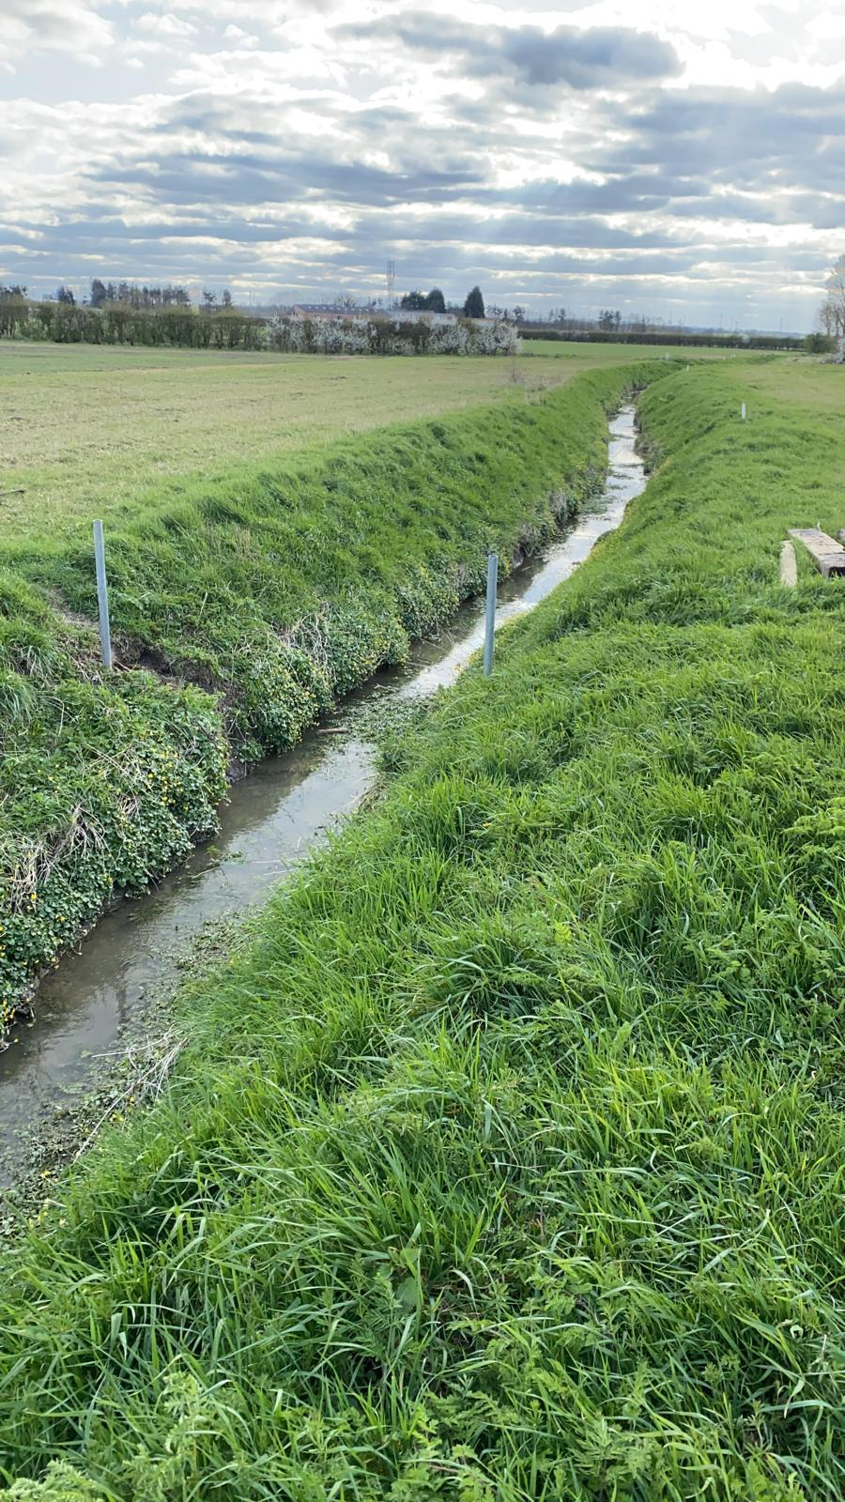

I have responded to Harry that we are grateful for anything that aids the flow of water along Beck Brook.

Mary Rodger
13 April 2021

